INFRASTRUCTURE

- The department of orthodontics and dentofacial orthopedics is located on thefourth floor ofthemainbuildingoftheChettinaddentalcollege,ChettinadhealthcityCampus.
- Thedepartmentisspreadacrossanareaofaround12500sqfeet.
- The facilities are designed specifically for the Graduate OrthodonticProgram and are adequate to serve the needs of theProgram.
- It has a spacious UG and PG Clinic with modern facilities, well equipped laboratory, well maintained record room, and seminarroom.
- The total area of the Department is segmented and numbered according to the tabulation mentionedbelow:

Clinical Facilities

  - AnopenbayClinicincludingeight(18)fullyequippeddentalunits,
  - A receptionarea.
  - Fully equipped dentallaboratory.
  - Sterilizingroom.
  - Student seminarroom.
  - Head of the departmentroom
  - Reader Room
  - Lecturerroom
  - Cephalometric tracing and photographicroom
  - Departmentlibrary
  - Record room and storeroom

DEPARTMENT OF ORTHODONTICS AND DENTOFACIAL ORTHOPEDICS

FLOOR PLAN

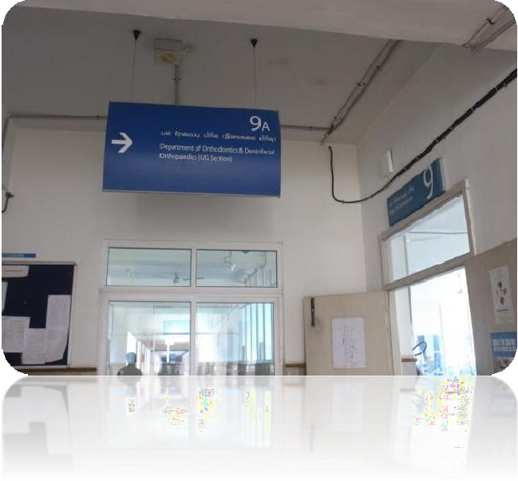
Department entrance

Patient waiting area

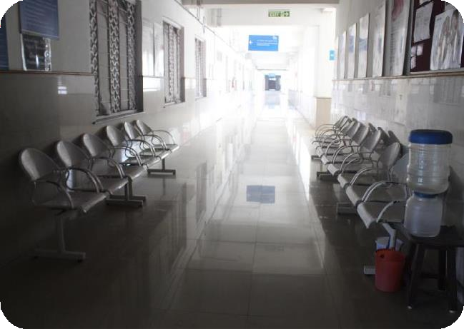

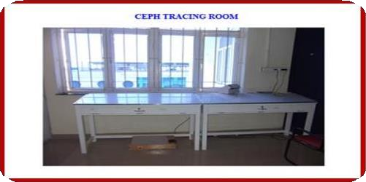
Ceph tracing room

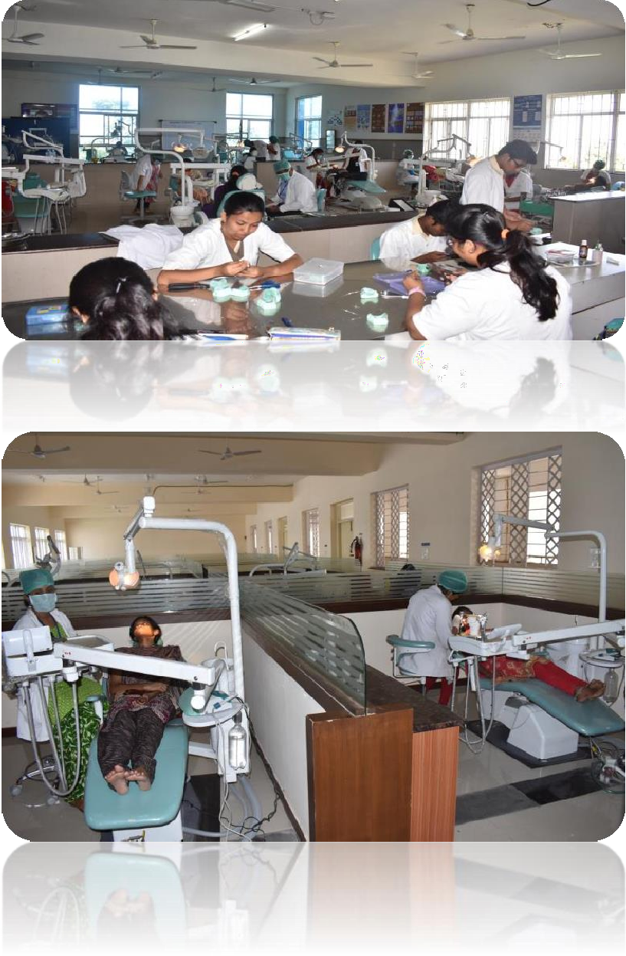
UG Clinic
PG Clinic

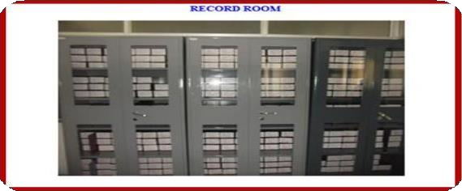
Record room

Seminar Room

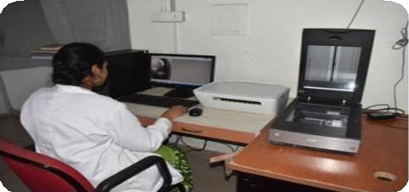
Digital ceph

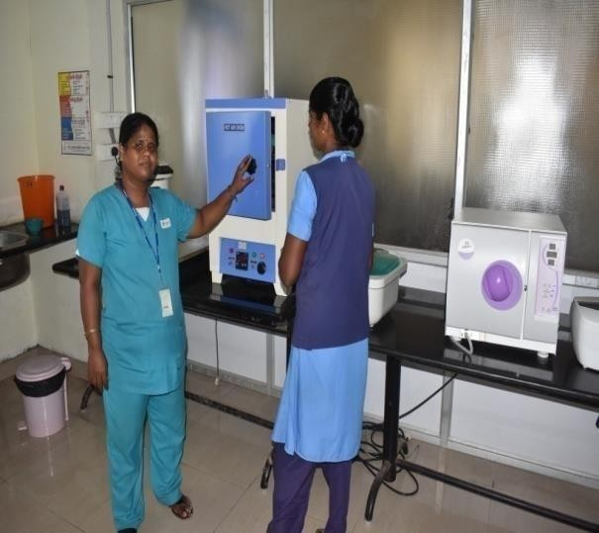
Sterilisation Room

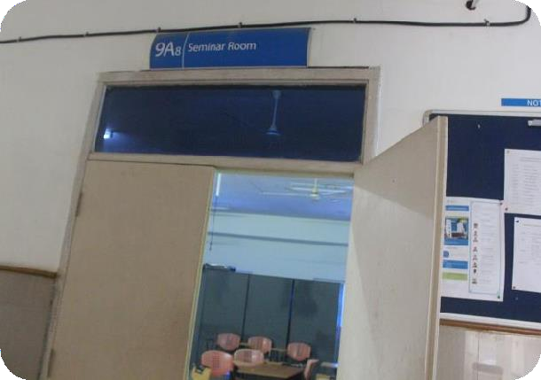

Seminar Room

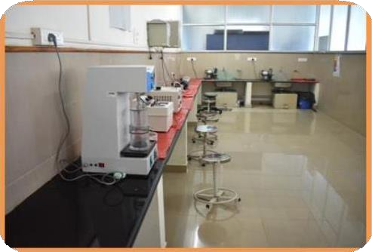
UG Lab

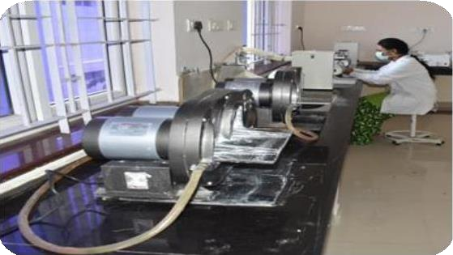
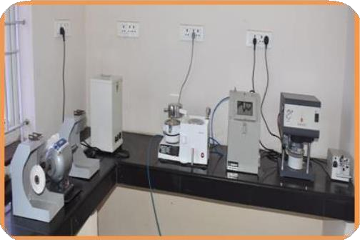
PG Lab
PG Lab

PG Lab

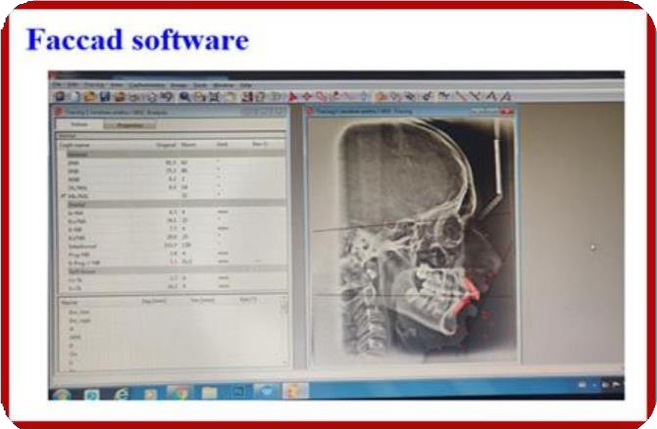
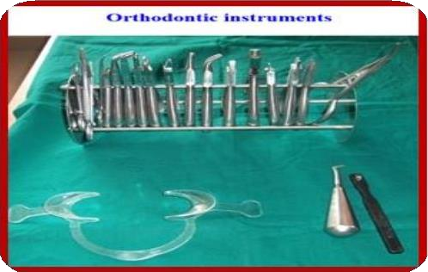

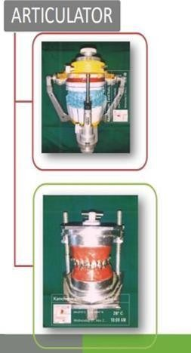
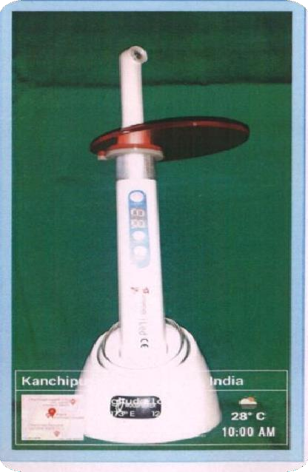
HIGH INTENSITY LIGHT CURE
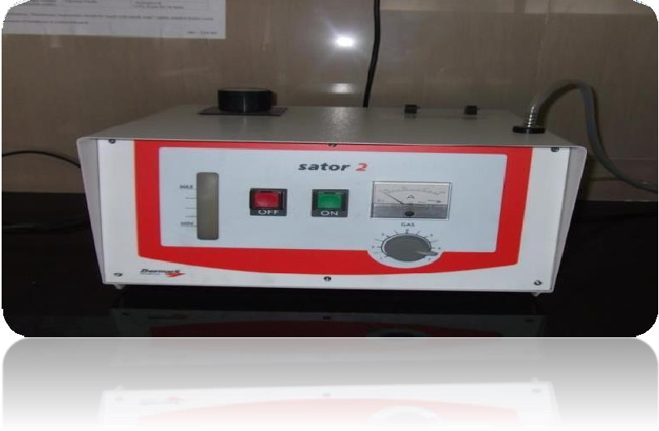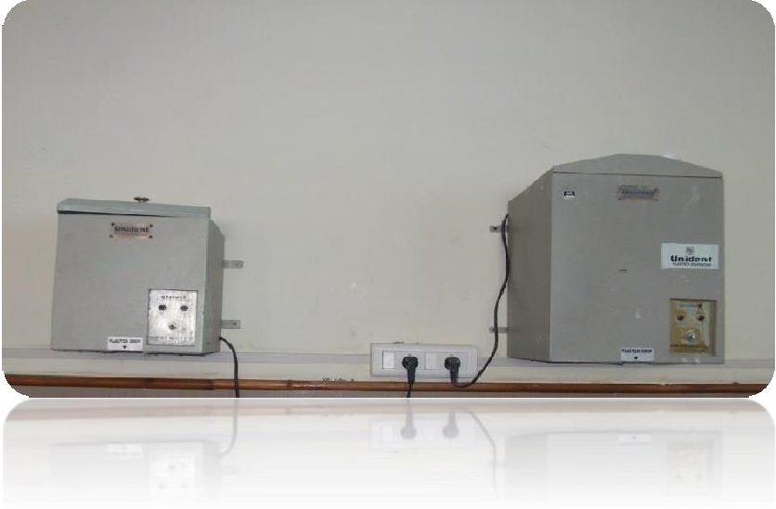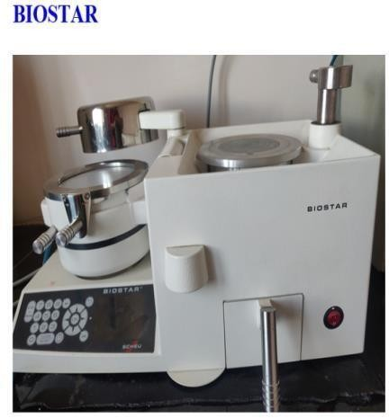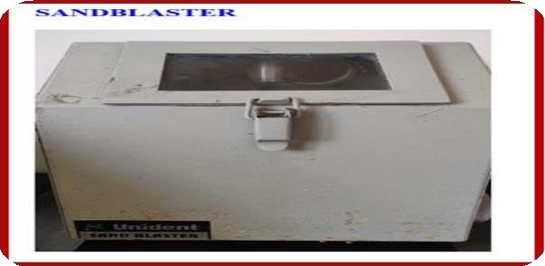
Hydrogen Solder
Plasticdispenser
Biostar
Sandblaster
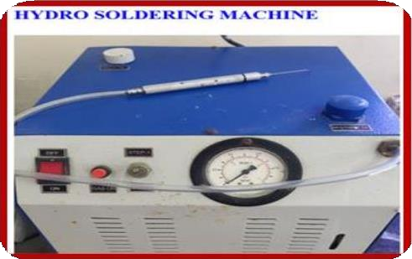
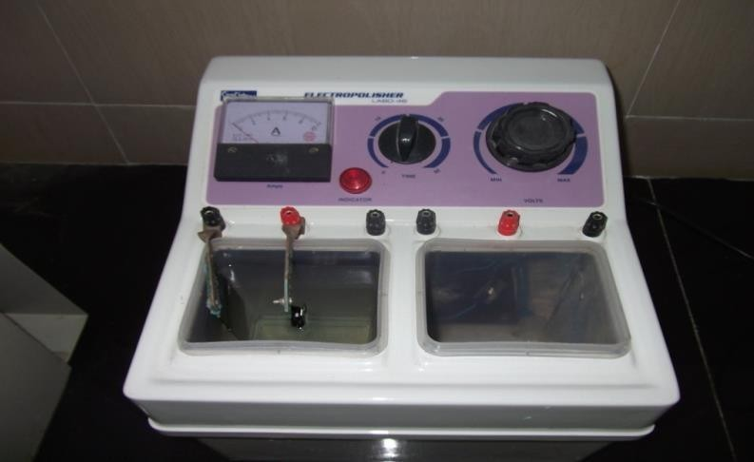
Electropolisher
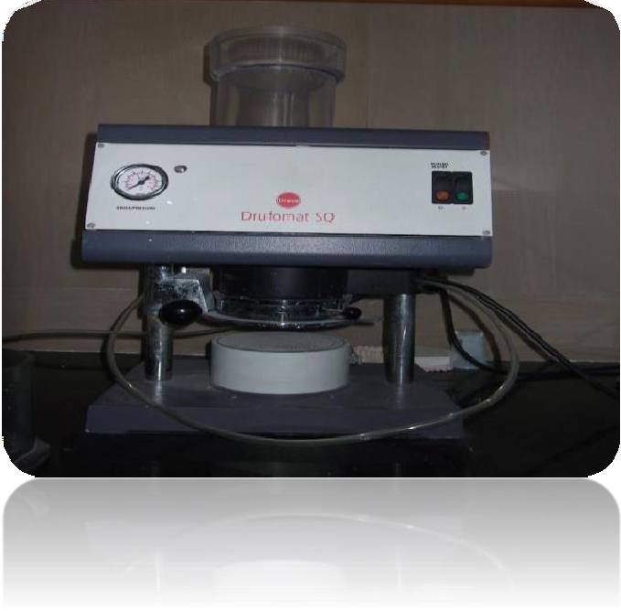
Vacuum molding machine
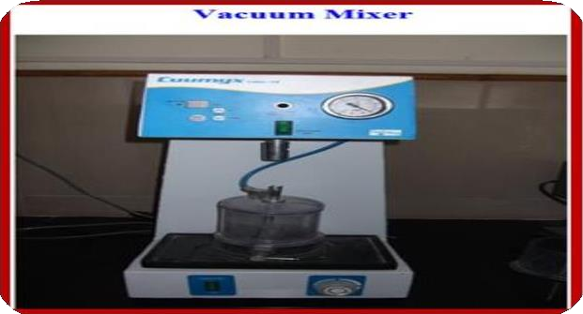
Vacuum mixer

